Single Sign-On (SSO) and Federation Setup using Microsoft Entra ID

1. Introduction
Single Sign-On (SSO) is a key capability in Identity and Access Management (IAM) that allows users to access multiple applications using a single set of credentials. It improves user experience while enhancing security by reducing password sprawl and centralizing authentication.
This project demonstrates the implementation of SAML-based SSO using Microsoft Entra ID, including federation setup, user authentication, and validation using logs.

2. Objective
The objective of this project is to:
- Configure SAML-based Single Sign-On (SSO)
- Establish federation between identity provider and application
- Authenticate users using centralized identity
- Validate SSO flow using test tools and logs
- Understand token-based authentication mechanisms

3. Tools & Technologies Used
- Microsoft Entra ID (Azure Active Directory)
- Azure Portal
- SAML (Security Assertion Markup Language)
- MyApps Portal
- Microsoft Entra Sign-in Logs

4. Architecture Overview
This project simulates an enterprise SSO architecture:
- Identity Provider (IdP): Microsoft Entra ID
- Service Provider (SP): Configured SAML Application
- User: Jane (Test User)
Authentication Flow:
User → Entra ID → SAML Token → Application Access
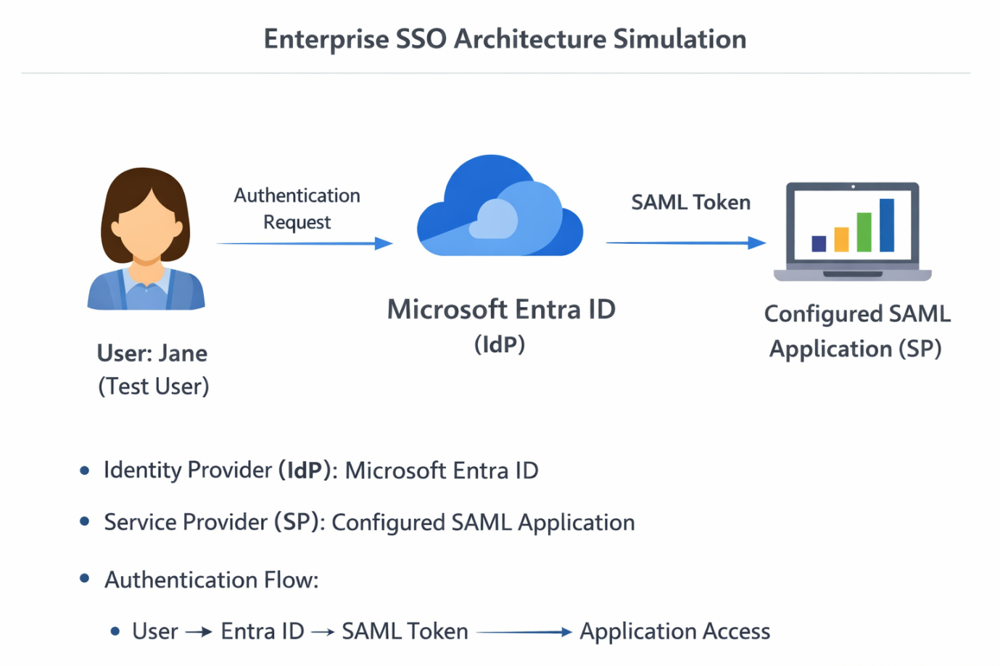
Architecture Diagram Setup

5. Environment Setup

Steps Performed:
- Logged into Azure Portal
- Navigated to Microsoft Entra ID
- Created Enterprise Application for SSO
- Verified tenant configuration

6. Application Creation

A custom enterprise application was created to simulate SSO integration.

Steps:
- Navigated to Enterprise Applications
- Clicked “New Application”
- Selected “Create your own application”
- Chose “Integrate any other application” and “Name the application”(SSO-Lab-App).
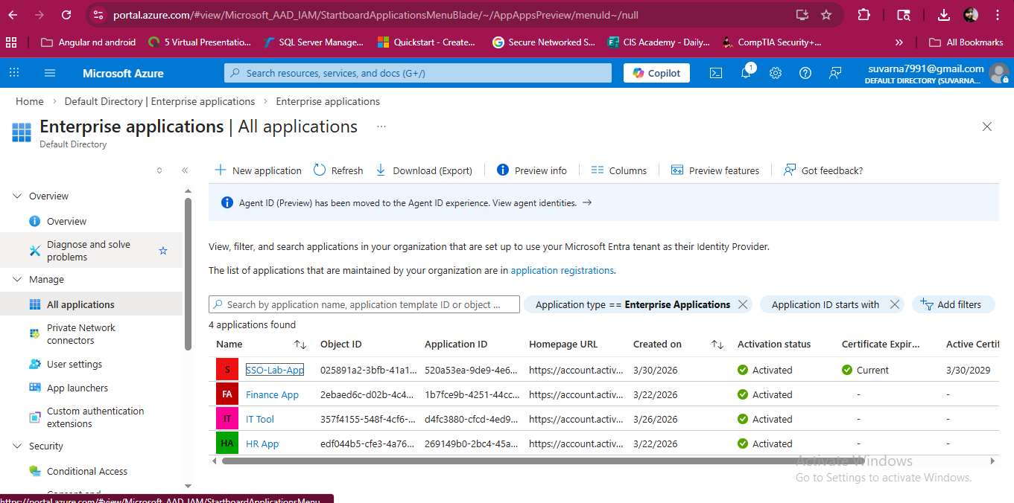
SSO Application Creation

7. SAML Configuration

SAML-based Single Sign-On was configured for the application.

Steps:
- Opened application → Single Sign-On
- Selected SAML as authentication method

Basic SAML Configuration:
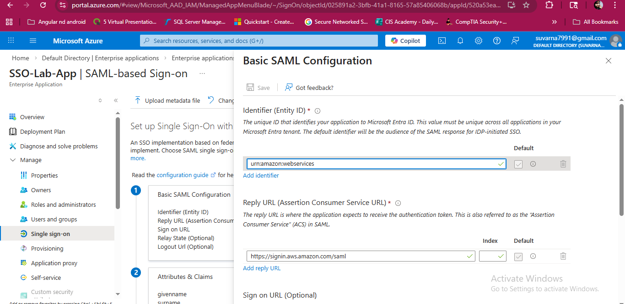
SAML Configuration
These parameters define how the application and identity provider communicate securely.

8. Federation Setup
Federation establishes trust between the identity provider and the application.

Configuration Details:
- Azure AD Identifier
- Login URL
- Logout URL
- Federation Metadata XML
These values are used by the service provider to trust authentication requests from Microsoft Entra ID.
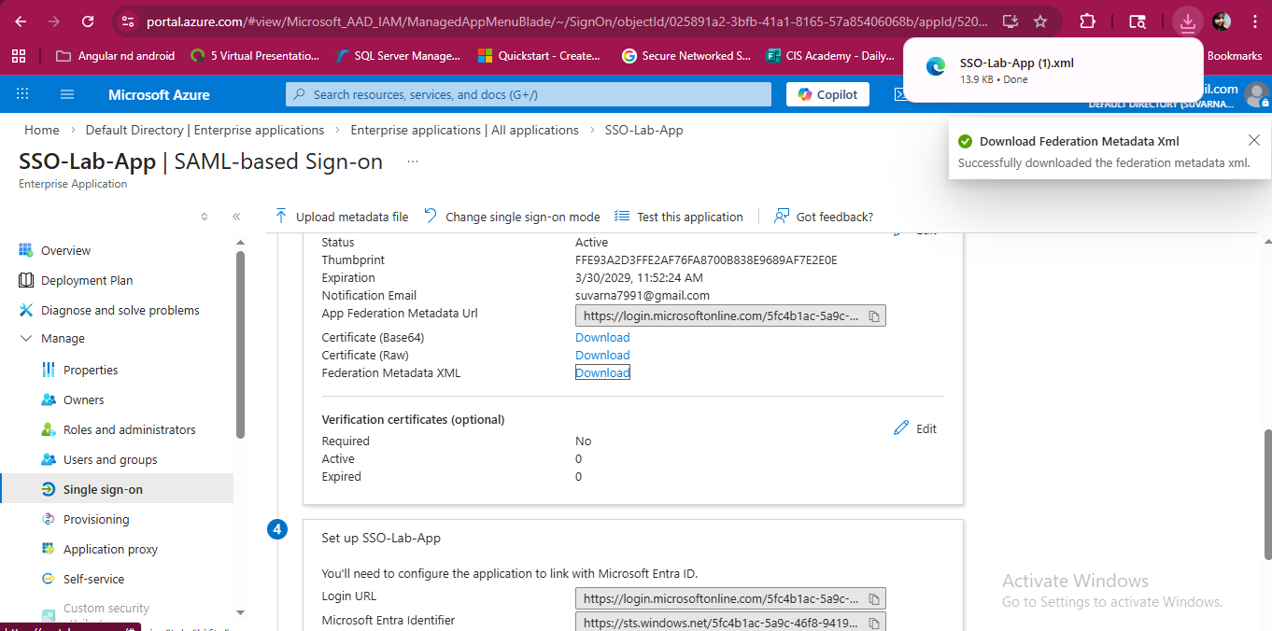
Federation Metadata XML

9. User Assignment
Users must be assigned to the application for access.

Steps:
- Navigated to Users and Groups
- Added user (Jane)
- Assigned to application
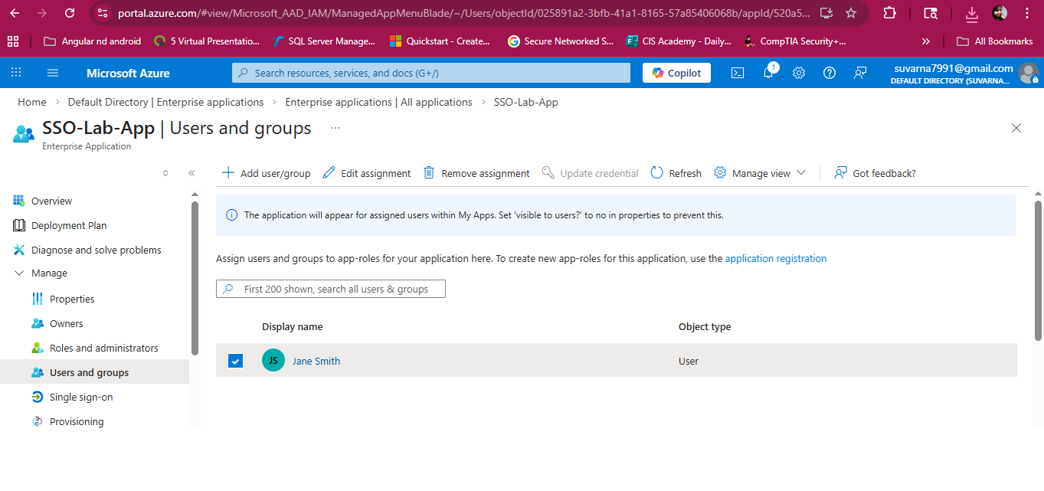
SSO User Assignment

10. SSO Testing and Validation
SSO was tested using built-in Azure functionality.

Steps:
- Navigated to Single Sign-On → Test
- Selected “Test sign in as current user”
- Logged in as Jane

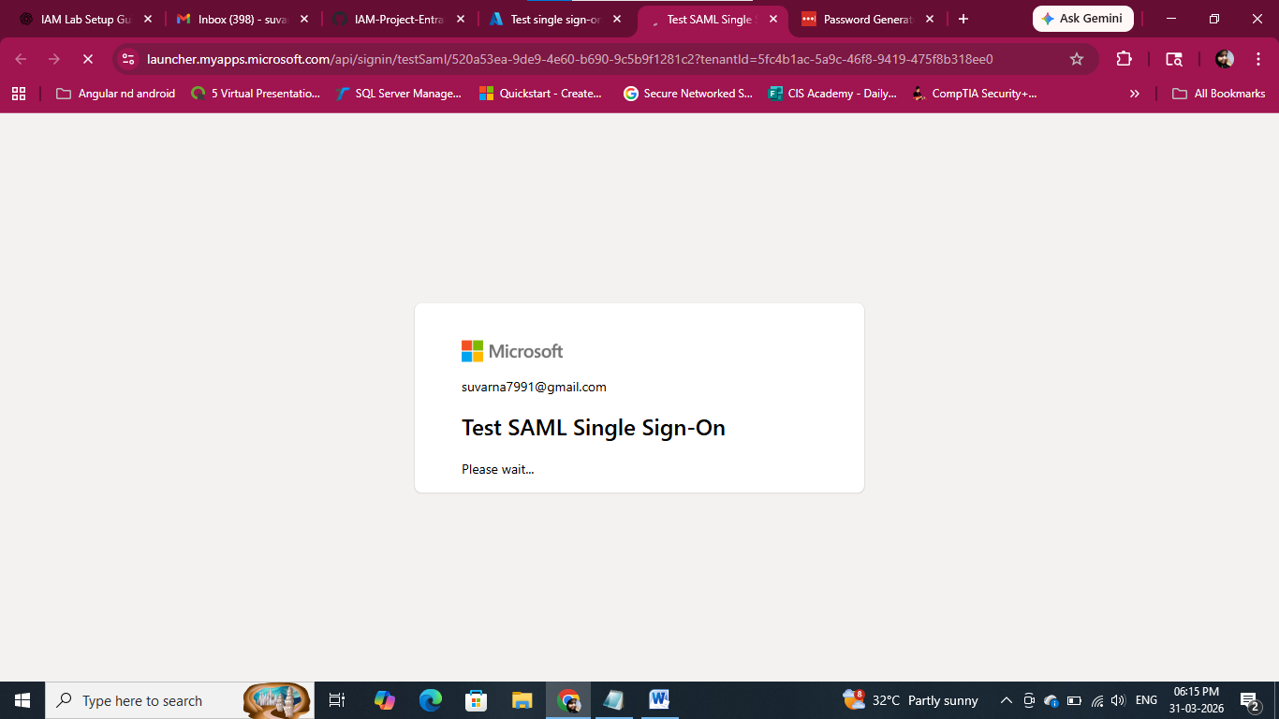 SSO Test Succes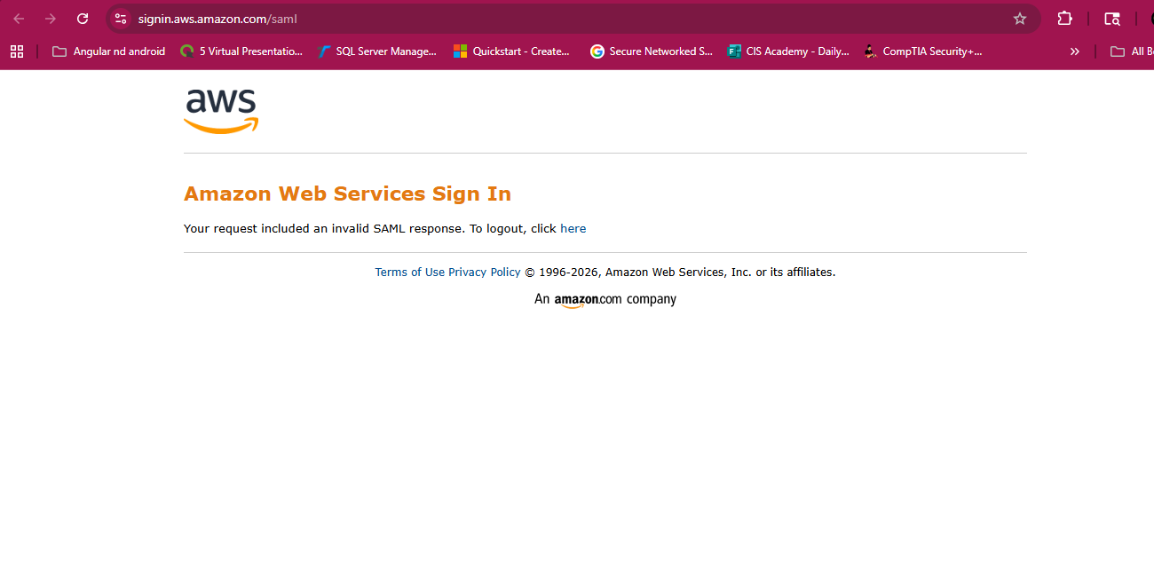
Result:
- Authentication successful
- SAML token generated
- User access validated

11. Sign-in Logs Verification
Authentication was validated using logs.

Steps:
- Navigated to Entra ID → Sign-in Logs
- Filtered by application and user

Result:
- Status: Success
- User: Jane
- Application: SSO App
This confirms successful SSO authentication and token exchange.
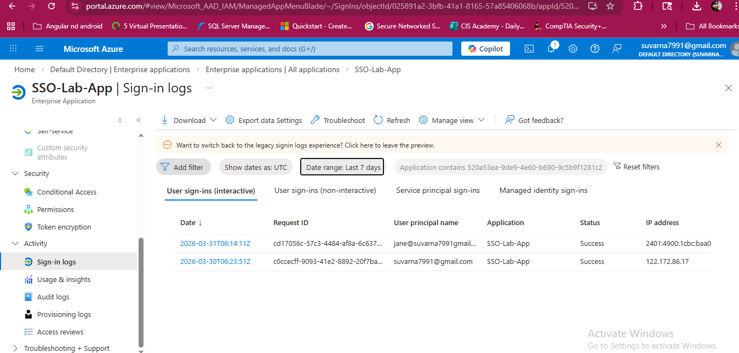
SSO_Sign-in Logs Screenshot

12. Negative Testing (Access Control)
Access control was validated through testing.

Scenario:
- User removed from application
- Attempted login again
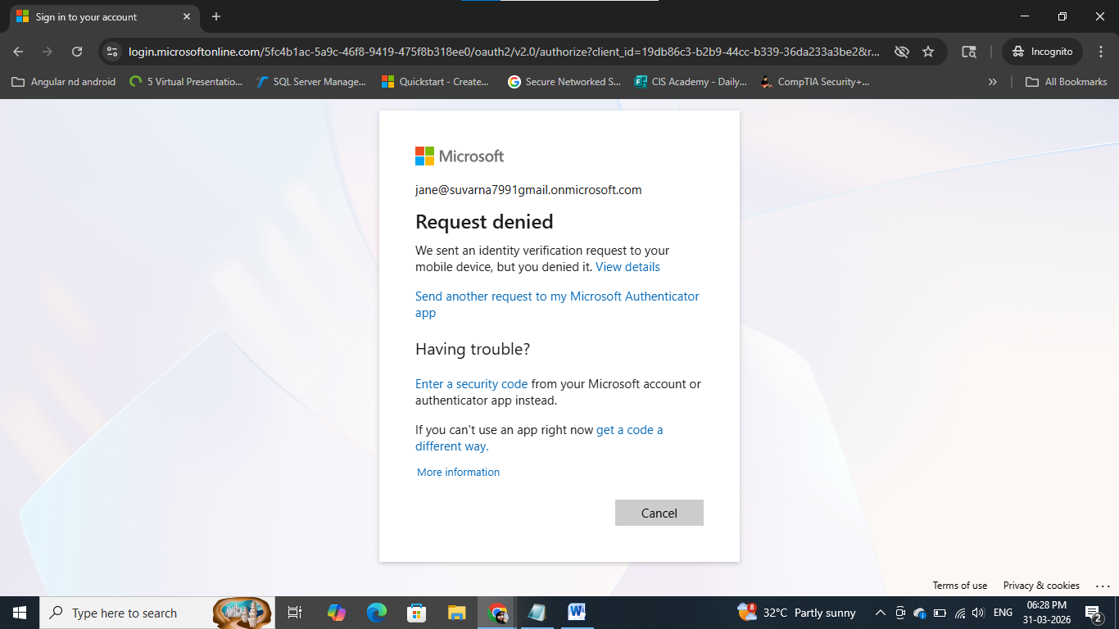
Access Request Denied
This confirms that authorization is enforced along with authentication.

13. Key Concepts Explained

Single Sign-On (SSO)
Allows users to authenticate once and access multiple applications without re-entering credentials.

SAML (Security Assertion Markup Language)
A protocol used to exchange authentication data between identity provider and service provider using XML-based tokens.

Federation
A trust relationship between identity provider and application that enables secure authentication.

Token-Based Authentication
Instead of passwords, authentication is handled using secure tokens (SAML assertions).

14. Challenges and Troubleshooting

Issues Faced:
- External SAML test applications were unavailable or unreliable
- Initial configuration errors in SAML endpoints

Resolution:
- Used Azure built-in SSO test functionality
- Validated authentication using sign-in logs
- Corrected SAML configuration parameters

15. Key Learnings
- Understanding SAML-based authentication flow
- Configuring SSO using Microsoft Entra ID
- Establishing federation between systems
- Troubleshooting SSO issues using logs
- Validating authentication without external dependencies

16. Conclusion
This project successfully demonstrates the implementation of SAML-based Single Sign-On using Microsoft Entra ID. The configuration enabled centralized authentication, reduced password dependency, and ensured secure access management.
The use of built-in test tools and sign-in logs validated the successful authentication flow and federation setup, reflecting real-world IAM practices.

17. Future Enhancements
- Integrate with real enterprise applications
- Implement OpenID Connect (OIDC)
- Configure Conditional Access policies
- Enable multi-application SSO
- Automate SSO configuration using PowerShell

